**GAS LEAKAGE MONITORING AND ALERTING SYSTEM**

INTRODUCTION:

Gas leakage leads to various accidents resulting in both material loss and human injuries. The risk of explosion, firing, suffocation are based on their physical properties such toxicity, flammability, etc. The number of deaths due to explosion of gas cylinders has been increasing in recent years. The reason for such explosion is due to substandard cylinders, old valves, worn out regulators and lack of awareness in handling gas cylinders. The LPG or propane is a flammable mixture of hydrocarbon gases used as fuel in many applications like homes, hostels, industries, automobiles, vehicles because of its desirable properties which include high calorific value, less smoke, less soot, and harm the environment. Natural gas is another widely used fuel in homes. Both gases burns to produce clean energy, however there is a serious problem of their leakage. Being heavier than air, these gases do not disperse easily. It may lead to suffocation when inhaled and may lead to explosion.

PROBLEM STATEMENT:

We design and develop a propose system which include some safety factors. A safety has been a major issue in today’s day to day life. LPG and CNG i.e. petroleum gas and compressed natural gas are most commonly used in residential and commercial places for cooking purpose and in various vehicles as a replacement for costly fuels like diesel, petrol . These gases are filled in cylinders which are easily un-damageable. But leakage can take place through pipes or regulators or knobs which may cause accidents like suffocation, uneasiness or sometimes may catch fire and short circuit as well. The main aim of this project is developing a system that can detect gas leakage . On detection it will send an alert SMS and the gas supply knob of cylinder will be switched off automatically.

HARDWARE REQUIREMENT:

* Arduino UNO
* MQ series sensors
* Breadboard
* Buzzer

FEATURES:

* This project helps to monitor the leakage of unwanted gas in the field of Industries
* In several areas, the gas sensors will be integrated to monitor the gas leakage. In any area if the gas leakage is detected then the admins will be notified along with the location.
* In the web application, admins can view the sensor parameters.

TECHNICAL ARCHITECTURE:

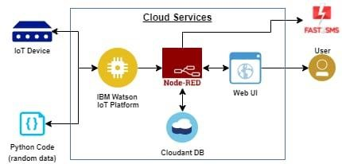

CONCLUSION:

The design of a sensor-based automatic gas leakage detector with an alert and control system has been proposed and discussed in this paper. This is a low-cost, low power, lightweight, portable, safe, user friendly, efficient, multi featured and simple system device for detecting gas. Gas leakage detection will not only provide us with significance in the health department but it will also lead to raise our economy, because when gas leakage happens it will not only contaminate the atmosphere but also the wastage of gases will downgrade our economy. In future, more advanced features will be integrated with this system which will provide users more safety and composure. The proliferation of handheld devices has led to developments in the field of smart gas sensors, which has considerably widened their scope of application. The need for ensuring safety in workplaces is expected to be the key driving force for the market over the coming years.